http://www.techrepublic.com/article/net-compilation-demystified/1045142
An application stays in MSIL form until it's executed, at which time it is just-in-time (JIT) compiled into native code. Figure A illustrates this process.

Figure A
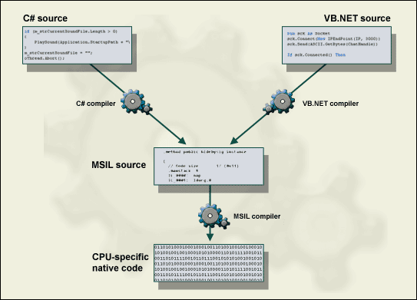
.NET's compilation process, from source to native instructions
JIT compilation occurs at the assembly level whenever an assembly is first loaded. When a reference to an object is first encountered, the JITer loads a stub for each method that matches that method's declaration. When a method is later invoked, the IL for it is compiled and the stub is replaced with the address of the method's compiled code. This happens each time a method is invoked for the first time, and the resulting native code is cached so that it can be reused the next time the assembly is loaded during that session. Obviously, this execution system results in more required overhead than that for a traditional compiled language, but not as much as you'd think.
That should clear up one common misconception: that .NET applications are interpreted. Another common misconception is that the JIT compiled code is stored on disk and reused for subsequent executions of the same application. While it's possible to do so, as you'll see shortly, this is not the default arrangement. The IL code for an application is recompiled into native code each time that application is run.
The economy JITer represents the bare minimum functionality needed to run a .NET application, it directly replaces each MSIL instruction with equivalent native code, doing no optimization, thereby consuming less overhead. It's meant for use on platforms where memory resources are at a premium.
The normal JITer, which is the default runtime configuration, can perform quite a few on-the-fly optimizations to the code it produces. The JITer can adjust to the exact current runtime situation, allowing it to do some things that precompiled languages cannot:
- Utilize and allocate CPU registers more efficiently
- Perform low-level code optimizations when appropriate, such as constant folding, copy propagation, elimination of range checking, elimination of common subexpressions, and method inlining
- Utilize memory more efficiently by monitoring the current demand for physical and virtual memory during execution
- Take advantage of the exact processor model in use by emitting instructions specifically for it
The Pre-JIT compiler (otherwise known as the Native Image Generator or Ngen.exe), on the surface, offers a remedy for any performance problems. The Pre-JIT compiler is meant to be invoked before runtime, like at install time, and it compiles all MSIL in an assembly into native code. This native code is then stored in a special part of the Global Assembly Cache for later use, bypassing the JIT compilation process altogether.
At first glance, this sounds like a winner, particularly for client-side code. But the normal JIT performs lots of on-the-fly optimizations while compiling MSIL. Many of these optimizations, particularly those involving the use of registers and memory, are driven by the current demands made on the system. Compiling assemblies in one large batch prevents these optimizations from being made and therefore may actually result in slower final code. Before you go this route, Microsoft recommends that you do your homework and profile both JIT and Ngen versions of the same assembly on the target platform under conditions approximating those found under normal use.

Steps in Compiling Source Code

